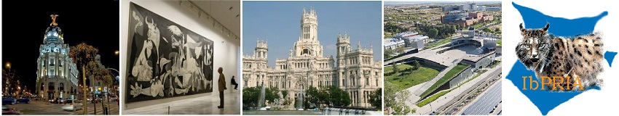

IbPRIA 2019: 9th Iberian Conference on Pattern Recognition and Image Analysis

Demo expression of interest form

Corresponding author name: …………………………………....………..………………………....…………………………. Corresponding author email: …………………………………...…………………………………....…………………………. Affiliations (Company/University): …………………………………....…………………………………...…………………. Address (Country/City): …………………………………....…………………………….…....………………………………….. Telephone: ………………………………………………………………………………………………………………………………….. Demo title: …………………………………………………………………………………………………………………………………..
……………………………………………………………………………………………………………………………………………………..

Authors names & affiliations: …………………………………....…………………………………....…………………….....

……………………………………………………………………………………………………………………………………………………..

Abstract (max 100 words): …………………………………………………………………………………………………………..

……………………………………………………………………………………………………………………………………………………..
……………………………………………………………………………………………………………………………………………………..
……………………………………………………………………………………………………………………………………………………..
……………………………………………………………………………………………………………………………………………………..
……………………………………………………………………………………………………………………………………………………..
……………………………………………………………………………………………………………………………………………………..
……………………………………………………………………………………………………………………………………………………..
……………………………………………………………………………………………………………………………………………………..
…………………………………………………………………………………………………………………………………………………….

Would you like to include an associated article with the demo (Optional: yes/no): …………………….

(If an article is also included follow the IbPRIA article instructions http://www.ibpria.org/2015/?page=submission and attach the files in the email)

Images (You can also attach videos in the email with this expression of interest form):

This form should be send by email to the demo organizers
For more information please visit: http://www.ibpria.org/2019/ or e-mail to the demo organizers:

Ruben Vera-Rodriguez. ruben.vera@uam.es
Roberto Paredes. rparedes@dsic.upv.es

CONSIDERATIONS

The presenters agree to accept the assigned space. The Conference will provide a table, two chairs, an electric outlet, and a poster board.

Insurance on all demo equipment is the responsibility of the demo presenter. The IbPRIA 2019 will not assume any responsibility for property loss or damage to personal property, as stated in the section on Limitation of Liability. You are advised and encouraged to carry insurance to cover your property against damage and loss and public liability insurance for claims of injury to the person and property of others.

Demo presenters agree that IbPRIA 2019 shall not be liable for any damage or liability of any kind or for any damage or injury to persons or property during the term of this agreement, from any cause whatsoever by reason of use, occupation, and enjoyment of demo space by demo presenter or any person thereon with the consent of demo presenter and that demo presenter will indemnify and hold harmless IbPRIA 2019 from all liability whatsoever, on account of such damage or injury, whether or not caused by negligence of or breach of an obligation by Exhibitor or its employees or representative.

